
ICG Digital Support
Digital Support Procedures
FMS Training

Target Points for FMS Training
- Logging In
- Testing eBook Links
- Miscellaneous

Logging In
FMS credentials should match your Lightning Source network credentials.
http://iweb.lightningsource.com/fmsadmin/FMSLogin.aspx?ReturnUrl=%2ffmsadmin%2fdefault.aspx
Testing eBook Links

FMS is used to test and create eBook links. To view the eBook you must have Adobe Digital Editions (ADE) installed on your machine.

The resting home screen of FMS is the Tool – Link Generator screen as seen below.

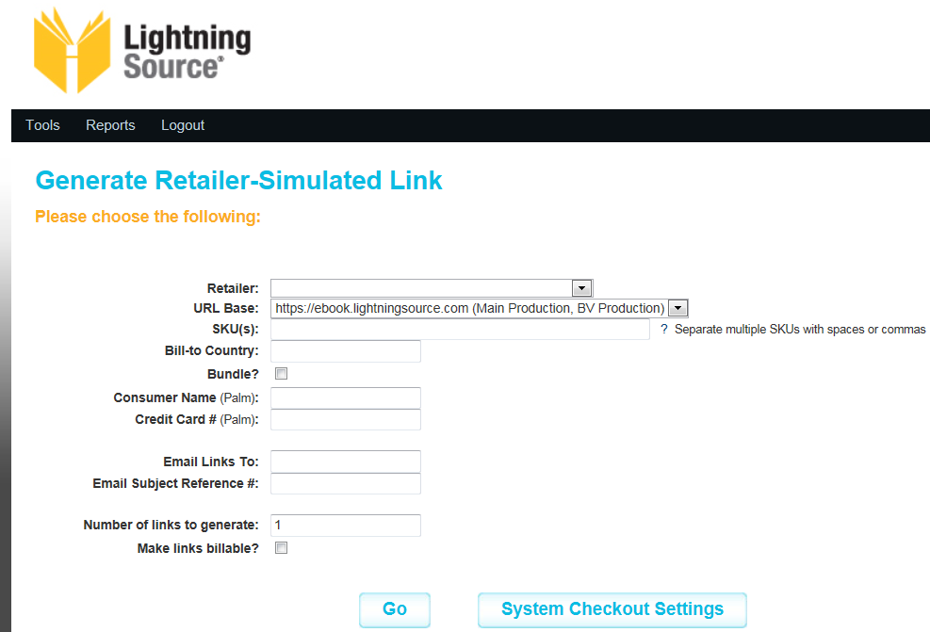

The Retailer field will allow you to select the Retailer from a drop down menu. When testing an eBook for our eBook Issues team, always try to test on the retailer account. If you are unable to determine or find the retailer account, you may test under the Test or LSI Proof account.

The URL Base should always remain on Main Production which is the default.

Enter the SKU.

Enter the Bill-to Country. This is the county code passed by the purchasing credit card. This is only needed when a specific
country is checked in the Rights tab of CMS. This information should be provided by the eBook Issues team.

Do not select Bundle.

The Consumer Name and Credit Card fields are no longer used.

Now select Go to test the link. An acsm file will open. The eBook will be opened in ADE. Here you can check for any error messages,
verify DRM rights, confirm page count, etc.

Miscellaneous

When testing a Wiley title you must select Wily as the retailer.

Please send any requests for replacement links to ebook.issues@ingramcontent.com. The Digital Support team should not be emailing links directly to retailers or responding to retailers.

